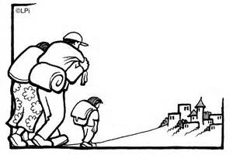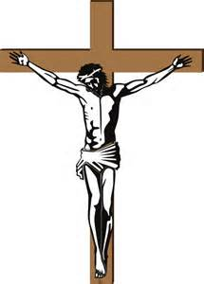

**“I am the way, the truth and the life; no one goes to the Father except by me.” John 14:6**

**Pilgrimage helps religious believers to show how much they love God.**

**Symbolism in places of worship**

**Christianity** varies from denomination; Quakers have very simple places of worship with limited symbols, whereas Catholic or Orthodox churches have symbols like **statues** of Jesus/Mary, **stained glass windows**, **altar** and **crosses**.

**Islam** has no pictures so that Muslims are not distracted from Allah. Instead, there is **calligraphy** with words from the Qur’an, the **mihrab** which faces Makkah, and **prayer mats**, allowing for a clean space to pray.

**Community** – a group of people who are joined together because they share something in common.

**Identity** – the sense of who you are in terms of attitudes, character and personality.

**Sacred** – something to be revered or respected above other things.

**Faith** – to have trust or confidence.

**Ummah** – the feeling of brotherhood amongst all Muslims.

**Pilgrimage** – a form of spiritual adventure.

**Hajj** – the pilgrimage to Makkah, the fifth pillar of Islam.

**Ihram** – white sheets worn by Muslims on Hajj.

**Umrah** – the lesser pilgrimage to Makkah, which can be undertaken at any time of the year.

**Interfaith** – when two or more religions work together in harmony.

**Evangelism** – spreading a faith or religion to others.

The **Catholic Agency for Overseas Development** state:

***“Our mission is to promote human development and social justice in witness to Christian faith and Gospel values.”***

They work because:

* All human beings have a right to dignity and respect
* Everyone has the right to the world’s resources
* They are inspired by scriptures

How they help:

* Education
* Community projects, i.e. well digging
* Campaigns against injustice
* Raises money for relief from natural disasters

**“For where two or three come together in my name, I am there with them.” Matthew 18:20**

[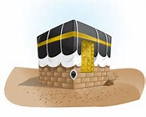](http://www.bing.com/images/search?q=hajj+clipart&qs=n&form=QBIR&pq=hajj+clipar&sc=0-8&sp=-1&sk=#view=detail&id=D6F5F57ADBE4B5836E67C34DAD9CBA0A560FE69E&selectedIndex=3)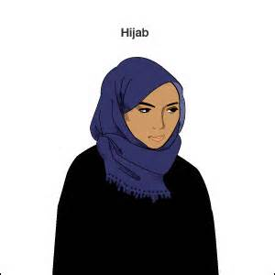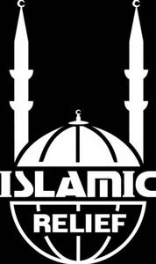

**Places of pilgrimage:**

Christianity – Lourdes, Canterbury Cathedral, Jerusalem

Islam – Hajj in Makkah

**Sharing faith**

* **Interfaith work** – Bradford District Faiths Forum. This helps community cohesion between different faith groups, working together to improve their community and stop any stereotypes.
* **Evangelism** – sharing the message of their religion to others, in order to convert them, because they believe they know something important and special.

**How do people express their religious beliefs?**

* **Joining in community worship** – their religion may tell them this is what God requires and they benefit from joining a community of fellow believers. Going to a place of worship can help people focus on God.
* **Displaying religious symbols and clothes** – this helps them keep their religion at the forefront of their mind, and is a public declaration of who they are and what they believe.
* **Pilgrimage** – people go to sacred places associated with their religion to draw them closer to God and help in their spiritual growth.
* **Helping others** – this could be a small act to a large commitment.
* **Private worship** – some believe that their faith is a deeply personal matter, and prefer to worship alone with God.
* **Missionary work** – some are convinced they have a duty to preach to others and encourage them to convert.

**Islamic Relief** aims to alleviate the suffering of the world’s poorest people and responds to disasters and emergencies, regardless of race, religion or gender.

The scriptures which inspires them:

“Whoever saved a human life shall be regarded as having saved all mankind.” (Qur’an 5:32)

“He who goes to sleep on a full stomach while his neighbour goes hungry is not one of us.” (Prophet Muhammad)

How they help:

* Campaigning
* Education
* Orphan sponsorship
* Emergency relief
* Health and nutrition
* Water and sanitation

**Why have symbols?**

To keep God at the forefront or their mind, show commitment or advertising their faith.

Examples:

* Salvation Army uniform
* Cross necklace
* Vicar’s robes
* Hijab
* ihram