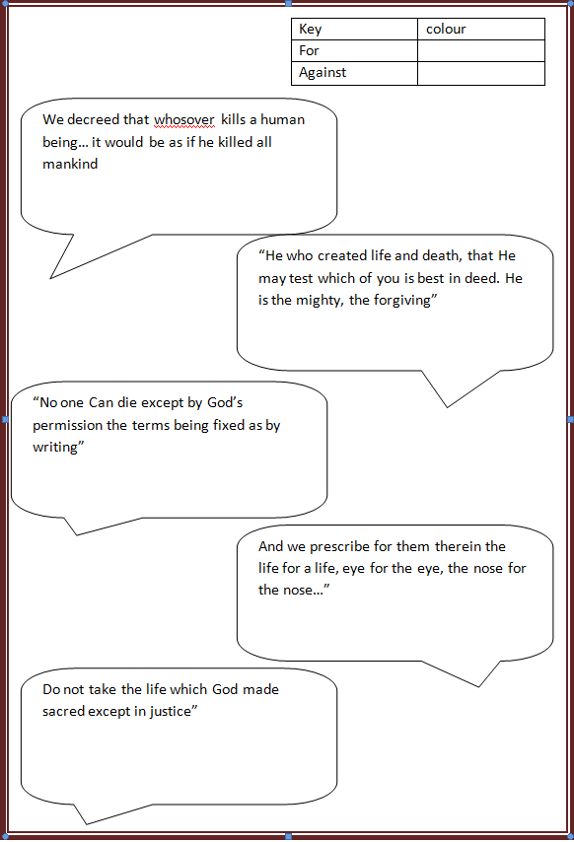

Do not take the life which God made sacred except in justice”

“No one Can die except by God’s permission the terms being fixed as by writing”

We decreed that whosover kills a human being… it would be as if he killed all mankind