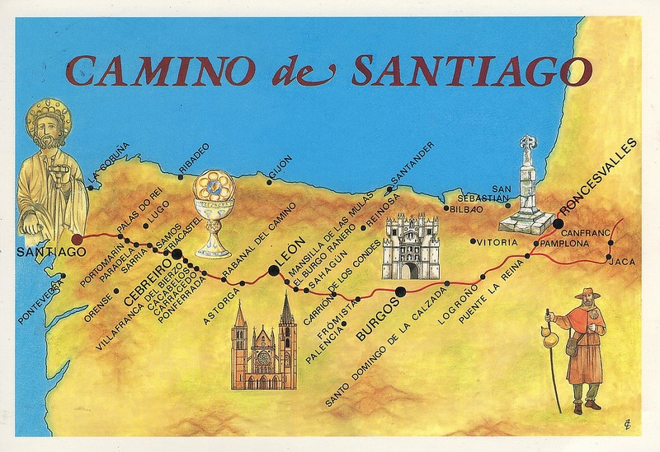
Camino de Santiago (St, James’ Way), Spain
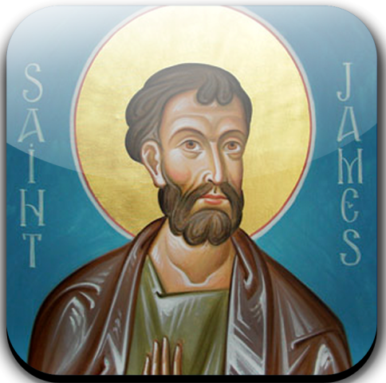
This is the name of the pilgrimage routes from parts of Europe to the shrine of the apostle St James the Great in the Cathedral of Santiago de Compostela in northwestern Spain. The tradition is that it has the remains of St James buried there, which were carried by boat from Jerusalem to Spain, after being beheaded in Jerusalem.
Many take up this pilgrimage for spiritual growth, either as a retreat (staying in one place, learning and praying) or as a spiritual path/journey.
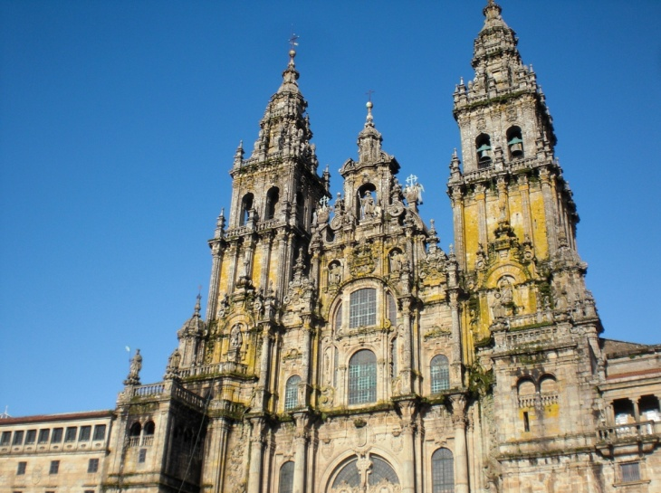
The Way can take one of dozens of pilgrimage routes to Santiago de Compostela. Today, pilgrims travel from their homes by foot, bike or even by horse. Many consider it an important pilgrimage to remove themselves from the busyness of modern life, and so they can have a spirtual adventure. Pilgrims also celebrate Mass (Holy Communion) at the Cathedral

