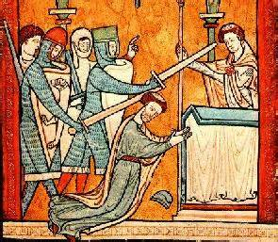
Canterbury Cathedral
Canterbury's importance as a major European pilgrimage destination began after the martyrdom of Thomas Becket on December 29, 1170. Becket, the archbishop of Canterbury and the most powerful religious figure in England, had angered Henry II, the King of England. In response to the king's question, "Who will rid me of this turbulent priest", four knights entered Canterbury cathedral and slew Becket with swords.
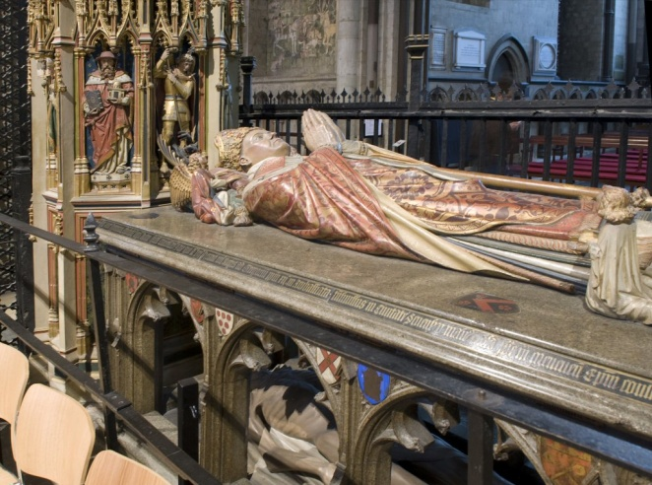
Whilst Becket was certainly no saint (he is known to have been an arrogant and greedy), his martyrdom (killed for a holy reason or in a holy place) gave rise to England's greatest pilgrimage tradition. The reasons for this may be found in the unjust circumstance of his murder, the coincidental occurrence of some miracles of healing immediately following the murder, the penance done at the shrine by Henry II four years later, and the wide spread medieval belief in the spiritual powers emanating from the relics of saints and martyrs.
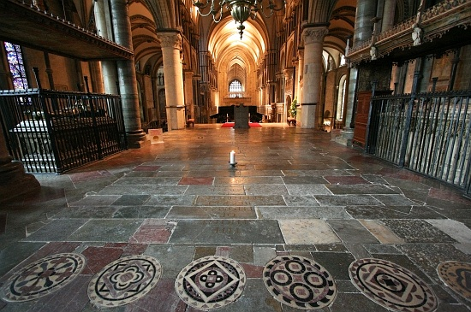
Today, pilgrims walk through Canterbury to Thomas Becket’s shrine, where they might touch his tomb for healing, or pray for healing. A candle always burns at his shrine.

