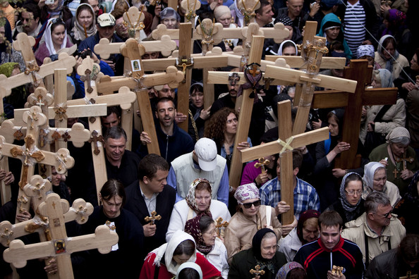
Jerusalem
For many Christians, the Holy Land is the only place they want to make a pilgrimage to. This is because they feel closer to Jesus when they are following in his actual footsteps. Some Christians draw strength from being in a group of believers, praying at the sites where Jesus is likely to have prayed.
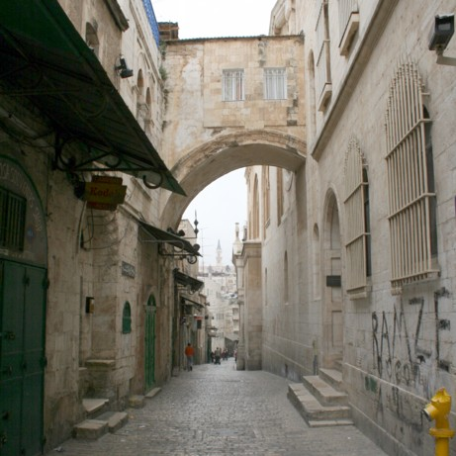
For others, this is a personal journey. They might stop to read passages from the Gospels about what Jesus did at the sacred place, and then they might pray there. For them, the effort of saving the money and arranging the travel is an expression of thehir faith, because a pilgrimage can bring them spiritually closer to God.
These are some of the places they might visit:
- Via Dolorosa
The meaning of Via Dolorosa, in Latin, is “Way of Grief” or “Way of Agony /Suffering”. It is a street, in the section of the old city of Jerusalem, which is historically believed to be the path that Jesus walked, carrying his cross, on the way to his crucifixion.
- Capernaum
One of the ancient sites relating to Jesus, near the Sea of Galilee. The site dates back to Jesus’ time, life and work. Many conquerors have made their home in this location, throughout the years after Jesus’ time.
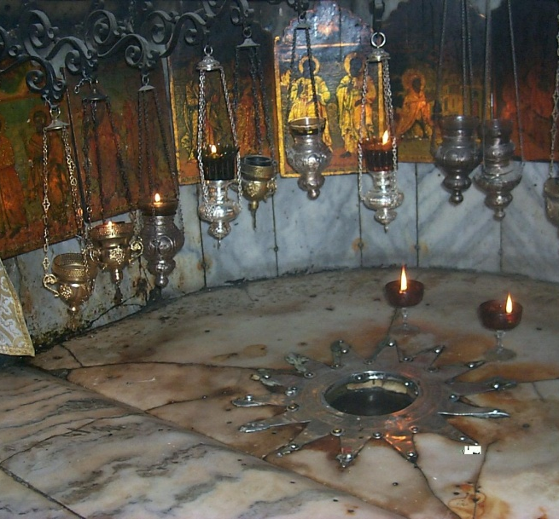
- The Mount of Beatitudes
Mount Naum is looking over the Sea of Galilee. Based on tradition, the Mount of Beatitudes is the place where Jesus held his important sermon (on the mountain) to the people who gathered to listen to him.
- Bethlehem
Christians might visit the place in Bethlehem where Jesus was born (in a cave).
Shrine in Bethlehem on the spot where Jesus was born

