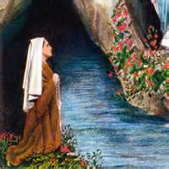
Lourdes, France
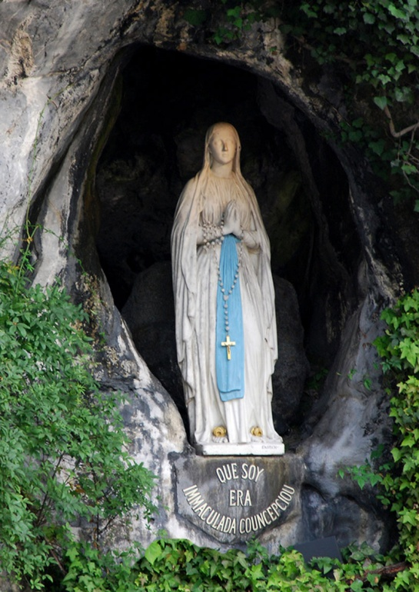
Lourdes is one of the largest Catholic pilgrimages in the world. The origins of the pilgrimage to Lourdes began with Bernadette Soubirous, the fourteen year old daughter of devout Christian peasants. Between February 11 and July 16, 1858, Bernadette saw visions of a white-robed lady 18 times in a small grotto called Massabiele, along the banks of the river Gave de Pau. In the apparitions the lady told Bernadette to "go tell the village priest to build a chapel here" and that many people would soon come in procession to the holy grotto. On the day of the 16th apparition, March 25, the lady revealed herself as Mary.
During her ecstatic trance in front of the grotto that day, Bernadette suddenly rose from her knees, walked a short distance, and fell to the ground. She began to dig in the earth until a small puddle of water appeared. Over the next few days the puddle gradually formed into a pool and eventually became the sacred spring for which Lourdes is now so famous.
In 1873, there began to be reports of healing at Lourdes,and the shrine rapidly developed a national and then international reputation for having therapeutic powers. Pilgrims visiting Lourdes for its healing powers bathe in pools filled with cold water piped from Bernadette's spring.
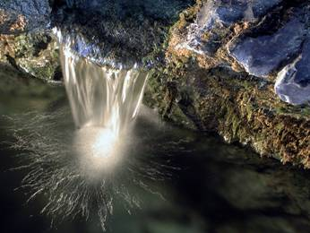
Catholics go to pray the Mary, and to be healed by the water at Lourdes. They might even buy water to take home with them for ill friends and family.

