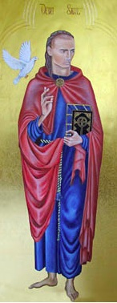
St David’s Cathedral, Wales
Since the 6th century there has been a church on the site of St. David’s Cathedral. For the past 1500 years prayer and worship has been offered to God on a daily basis and this continues to this day.
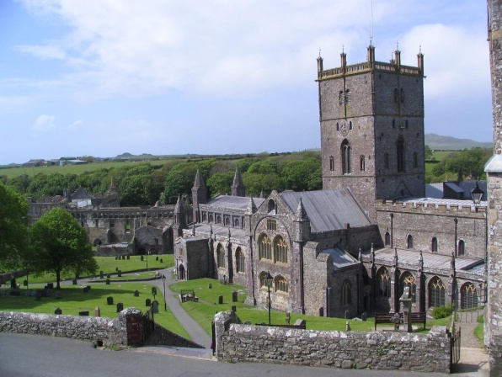
David was born in the year 500, the son of St Non and a prince of Ceredigion. Legend states that Non gave birth to him on a cliff top during a violent storm. Dewi Sant (or St. David, in English) was the only one of the Patron Saints who was born in the country he is remembered in. He founded a monastery in St. David’s, where the cathedral now stands. David traveled widely, telling people about Jesus. He was known as the ‘Water Man’ because he never drank alcoholic drinks, and he stood in cold water to help him concentrate on God.
David eventually become a bishop in the church and made several pilgrimages including one to Jerusalem during which, tradition states, he brought back with him a stone that now sits in an altar in the south transept of the cathedral.
The best-known miracle associated with David is said to have taken place when he was preaching in the middle of a large crowd at the Synod of Llanddewi Brefi. When those at the back complained that they could not hear him, the ground on which he stood is reputed to have risen up to form a small hill so that everyone had a good view. A white dove settled on his shoulder, a sign of God’s grace and blessing.
In the twelfth century Pope Calixtus II declared St David’s Cathedral to be a place of pilgrimage. Calixtus also stated that the shrine was so important that two pilgrimages to St David’s were equivalent to one to Rome, three were equivalent to one to Jerusalem. Since then the path of pilgrimage has been trodden by hundreds of thousands of individuals.
David died in the year 589 and tradition says that the monastery was ‘filled with angels as Christ received his soul’. His final words to his followers were:
‘Be Joyful. Keep the Faith. Do the little things that you have heard and seen me do.’
Today, pilgrims walk where St David walked, and say prayers at his shrine.

