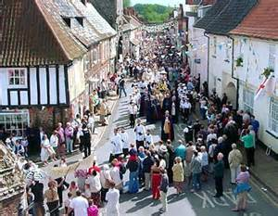
Walsingham, Norfolk
In 1061, a Saxon noblewoman, Richeldis de Faverches had a vision of the Virgin Mary and was instructed to build a holy house, like the one in Nazareth (where Jesus had lived). This house had in it a statue of Mary with a baby Jesus on her lap.
1. The Holy House.
About half a million pilgrims now visit Walsingham every year. Most of them go to the Holy House to spends time absorbing the atmosphere and contemplating the Motherhood of Mary, who is known as Our Lady of Walsingham. They feel the peace that has always been associated with the Holy House and relax in the silence They focus on the statue of Our lady of Walsingham and use it to centre their thoughts for worship
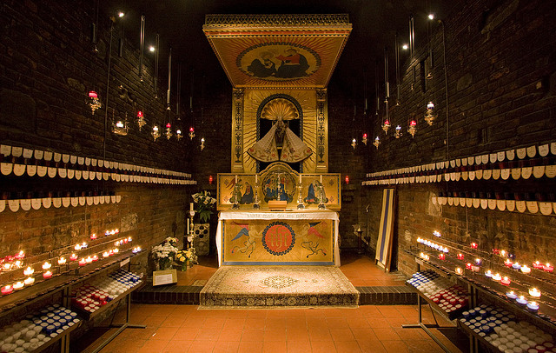
2. The Pilgrimage Church.
There are always a lot of candles burning in the Pilgrimage Church. They are lit either by the pilgrims or as a result of requests that come in by telephone and letter. Each is a symbol of a prayer that has been requested for someone or some situation. At six o’clock every evening, prayers are said for those in need or in trouble. This ceremony is called ‘Shrine prayers’.
3. The Stations of the Cross.
There are fifteen stations of the cross found in the grounds of the shrine, which pilgrims use to meditate on the sufferings of Jesus.
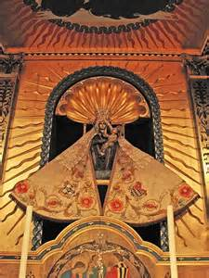
4. The Holy well.
There is usually a visit to the Holy Well to receive the Holy Water. They are blessed with the water and it is sprinkled on them. Sometimes they drink it too.
5. The Slipper Chapel.
In 1934 the Roman Catholics restored the ancient Slipper Chapel, placing a statue there. This is about one mile outside the village and it is where mediaeval pilgrims left their shoes to walk the last mile barefoot. Recently a Chapel of Reconciliation has been built nearby.

